
RAMAIAH
Institute of Technology
USN | 1 | M | S

(Autonomous Institute, Affiliated to VTU)
(Approved by AICTE, New Delhi & Govt. of Karnataka) Accredited by NBA & NAAC with ‘A’ Grade

SEMESTER END EXAMINATIONS – JANUARY 2019

Course & Branch | : | B.E: Electrical and Electronics Engineering | Semester | : | V
Subject | : | Transmission and Distribution | Max. Marks | : | 100
Subject Code | : | EE53/EE503 | Duration | : | 3 Hrs

Instructions to the Candidates:
- Answer one full question from each unit.

 |  | UNIT- I
1. | a) | A transmission has a span of 250m is supported by towers at the same level. The area of the conductor is 1.29 cm². The breaking stress for the conductor is 4220 kg/cm². Assume factor of safety as 3. The wind pressure is 45 kg/m². Find the height of the conductor above ground level at which it should be supported if minimum clearance of 7 m is to be kept between ground and conductor. Assume density of conductor material as 8.9 gm/cm³. | CO2 | (10)
 | b) | Explain the following terms:  i) Feeders ii) Distributors and iii) Service mains. | CO1 | (06)
 | c) | Define factor of safety. State its importance. | CO2 | (04)
2. | a) | Compare and contrast underground cable with over head line for transmission and distribution. | CO1 | (06)
 | b) | Explain various advantages of high voltage transmission. | CO1 | (06)
 | c) | Two towers of height 40 m and 30 m respectively support a transmission line conductor at water crossing. The horizontal distance between the towers is 300 m. If the tension in the conductor is 1500 kg, find the clearance of the conductor at a point midway between the supports. Weight of the conductor is 0.8 kg/m. Assume bases of the towers to be at the water level. | CO2 | (08)
 |  | UNIT- II
3. | a) | Show that the inductance per unit length of an overhead line due to internal flux leakage is constant and is independent of size of conductor. | CO3 | (10)
 | b) | Derive an expression of inductance for a 3-phase overhead line with symmetrical spacing. | CO3 | (10)
4. | a) | Derive expression for line-to-line capacitance and line to neutral capacitance of single-phase line. | CO3 | (12)
 | b) | A single 3-phase line operated at 50Hz is arranged as equilaterally spaced with 2m, 2m and 3m sides. The conductor diameter is 0.6 cm. Find the inductance and capacitance per/km. The line is regularly transposed. | CO3 | (08)
 |  | UNIT- III
5. | a) | A 220kV, 3-phase transmission line is 40km long. The resistance per phase is 0.15Ω per km and the inductance per phase is 1.5923 mH per km. The line is supplying a 3-phase load of 381 MVA at 0.8 pf lagging. Find: (i) the voltage and power factor at the sending end of the line (ii) the voltage regulation and efficiency of the line. | CO4 | (10)
 | b) | Derive A, B, C, D constants of a medium length transmission line using nominal π method. | CO4 | (10)
6. | a) | Using nominal T method, find the expression for sending end voltage and current for a medium transmission line. | CO4 | (10)
 | b) | A 3 phase line delivers 3000 kW at a p.f. of 0.8 lagging load. If the sending end voltage is 33 kV. Determine i) Receiving end voltage ii) Line current iii) Transmission efficiency. The resistance and reactance of each conductor is 5Ω and 8Ω respectively. | CO4 | (10)
 |  | UNIT- IV
7. | a) | A string of 6 suspension insulators is to be graded to obtain uniform distribution of voltage across the string. If the pin to earth capacitance are all equal to C and the mutual capacitance of the top insulator is 10 C, find the mutual capacitance of each unit interms of C. | CO5 | (10)
 | b) | Prove that the most economical conductor size in a cable is d = D/2.718. | CO5 | (10)
8. | a) | Derive an expression for insulation resistance of a single core cable | CO5 | (08)
 | b) | A string of 6 insulator units has self capacitance equal to 10 times the pin to earth capacitance. Find:  i) Voltage distribution from top to bottom insulator as a percentage of the total voltage  ii) The string efficiency. | CO5 | (12)
 |  | UNIT- V
9. | a) | Explain different types of distribution systems with the help of neat sketches. | CO1 | (06)
 | b) | With neat diagram, explain DC distributor fed form both ends with unequal voltages. | CO1 | (06)
 | c) | A 2-wire distributor AG shown in Fig.9(c), 1200m long is fed at 250V, loads of 80, 70, 100, 90 and 60A are tapped from points B, C, D, E and F whose distances from A are 100, 250, 600, 800 and 1100 metres respectively. If the voltage at G is 210V, find the resistance per metre of distributor.  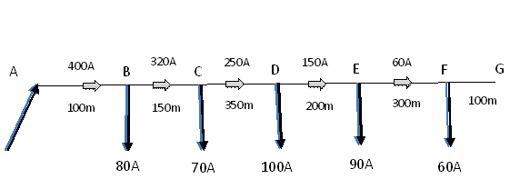  Fig. 9(c) | CO1 | (08)
10. | a) | With the help of phasor diagram, discuss the AC distribution when power factors referred to receiving-end voltage. | CO1 | (06)
 | b) | Discuss how AC distribution differs from DC distribution? | CO1 | (04)
 | c) | A single phase two-wire feeder, 1500 m long, supplies a load of 60A at 0.8pf; 40A at 0.85pf; and 50A at 0.88 pf lagging at distances of 600, 1200 and 1500 metres respectively from the feeding point. The resistance and reactance of the feeder per km length are 0.06 and 0.1 ohms, respectively. If the voltage at the far end is to be maintained at 220V, calculate the voltage at the sending end, and its phase angle with respect to the receiving end voltage.  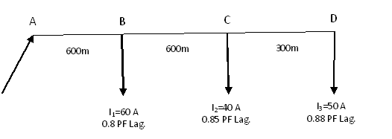  B  C  D  Fig. 10(c) | CO1 | (10)

****************

